Executive Board | 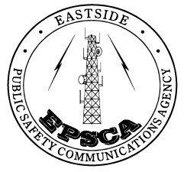 |  |  | Eastside Public Safety
City of Bellevue |  |  |  | Communications Agency
City of Kirkland |  |  |  | P O BOX 97010, Mailstop: PSEPS
City of Redmond |  |  |  | Redmond, WA 98073-9710
City of Mercer Island |  |  |  | Tel (425)556-2514 Fax (425)556-2517
City of Issaquah |  |  |  | 8701 160th Ave. NE, Redmond, WA 98052

Letter of Authorization

Authorization is granted to _______________________________ for the purpose of re-broadcasting EPSCA frequencies using Bi Directional Amplifiers (BDAs).
This authorization is made on a non-interference basis and EPSCA makes no warranties related to the system design or guarantees regarding future frequency or site changes that may affect the BDA owner.
The site choice is up to the group responsible for the installation and testing on behalf of the building owners.
Site name ___________________________________________________________________
Site address __________________________________________________________________
Site point of contact & phone number ______________________________________________
Location and model of BDA ______________________________________________________
Name & phone number of Installer ________________________________________________

Signed by
(On behalf of BDA Owner)
Print name & phone number _____________________________________________________
Signed by
(EPSCA Agent)
Date Signed

